利用Keras中的ImageDataGenerator增强数据

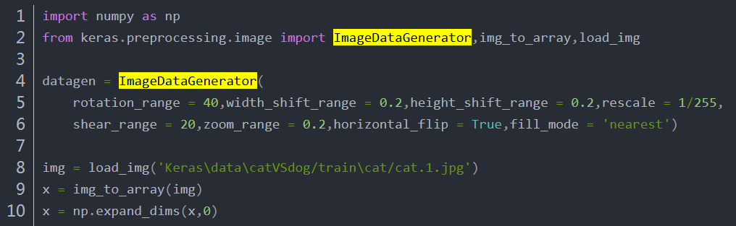
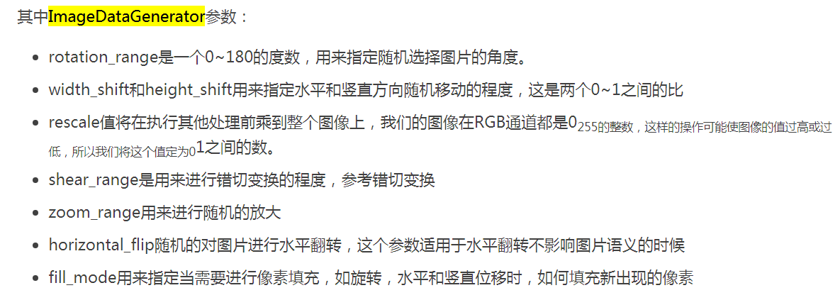
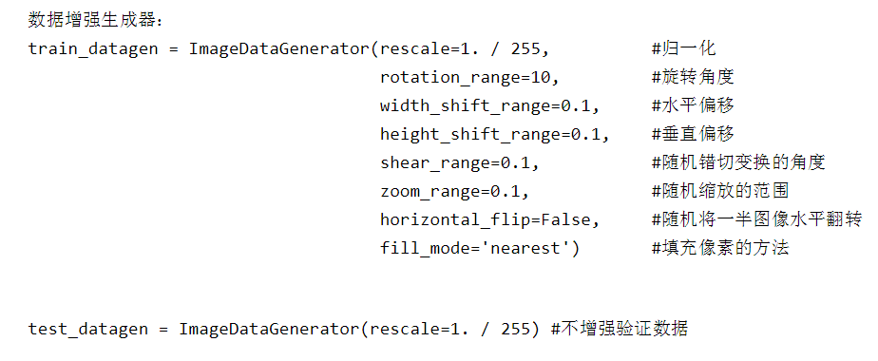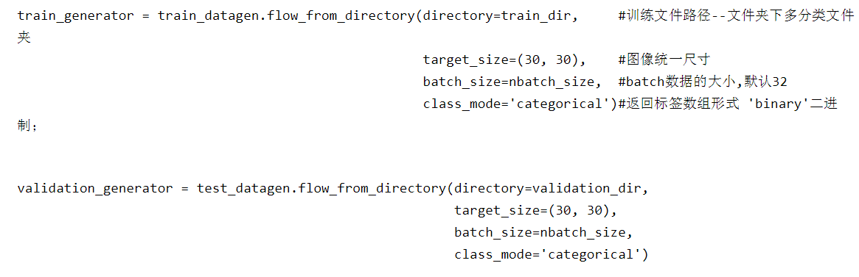
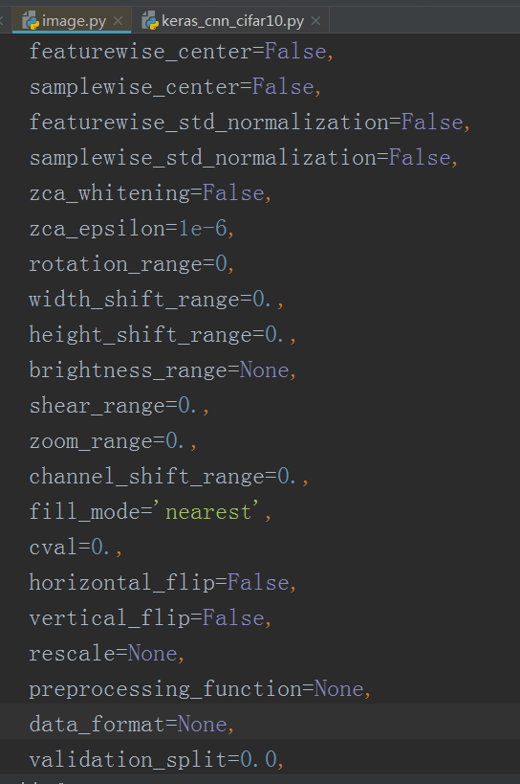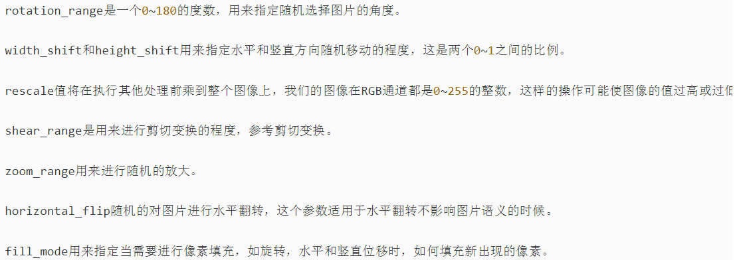

flow_from_directory
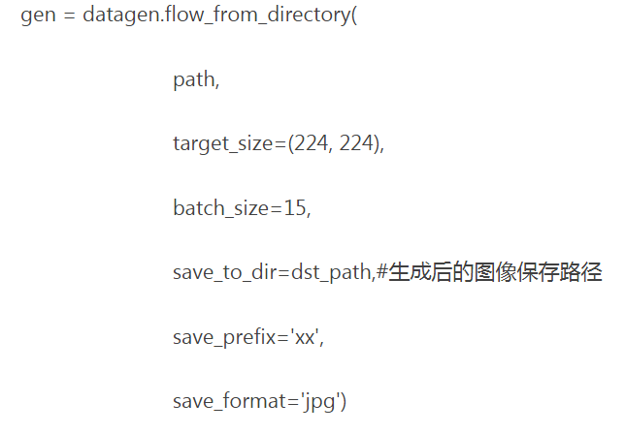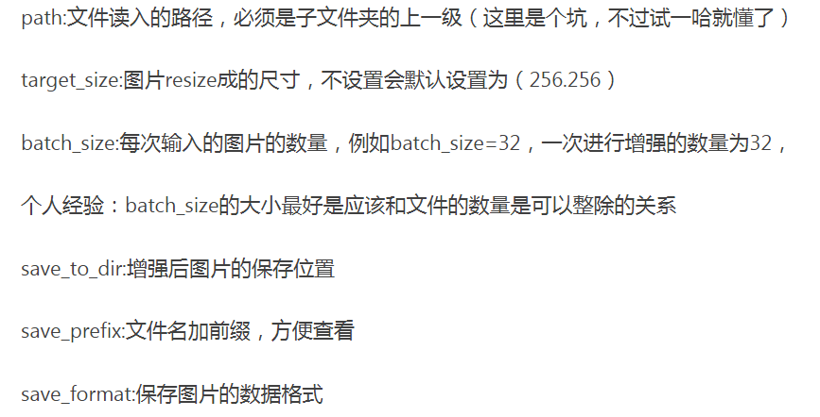
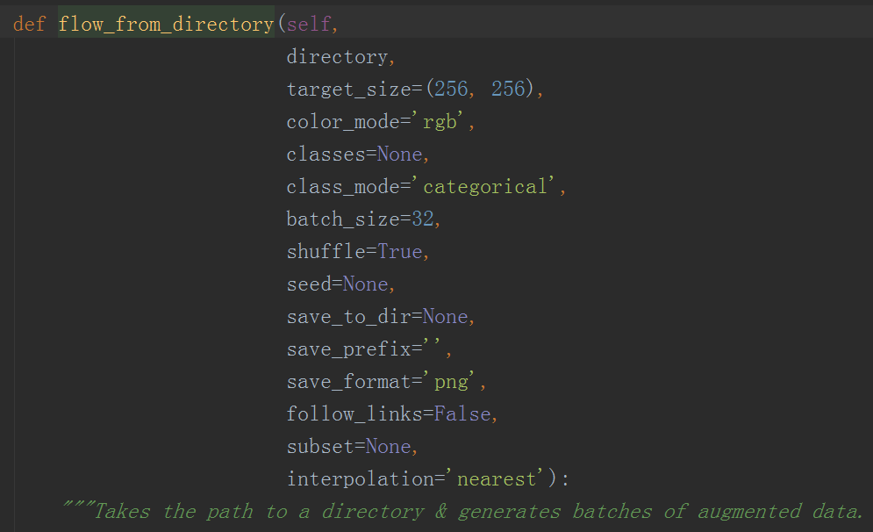
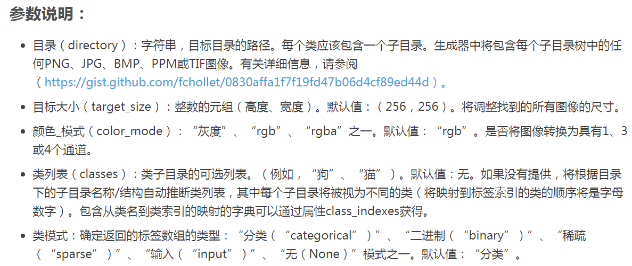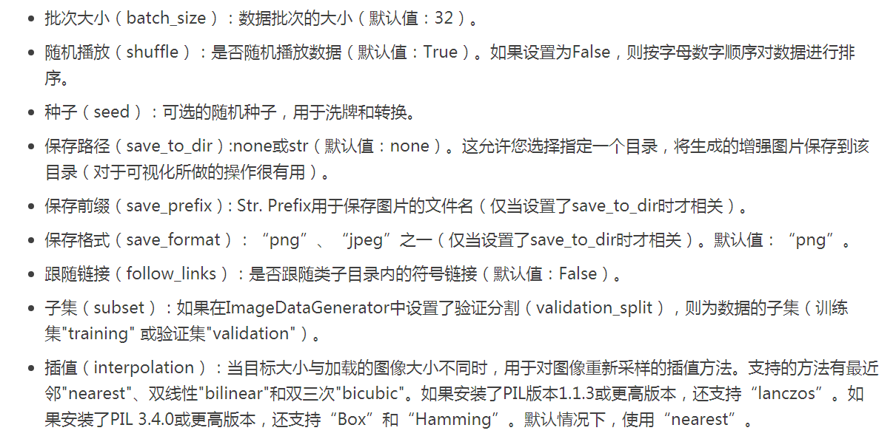
参考：
https://blog.csdn.net/PecoHe/article/details/88875886
https://blog.csdn.net/Harrison509/article/details/88855580
https://www.baidu.com/link?url=w7i9P0IM5mZv7_sTGq7aHj_s4kxFQM1qq5K-jB3ERLxoJEvXNJSwikbz4_6M1G63&wd=&eqid=967625c400020b62000000025e4b397f
https://zhuanlan.zhihu.com/p/44673440

